STAGING TABLE –

DETAILED SCREENSHOTS :

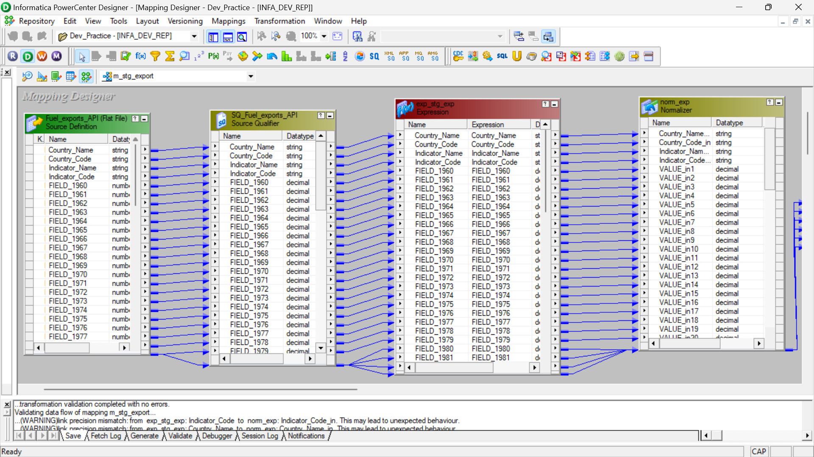

OVERALL MAPPING –

(ALL ICONIC – with proper naming)

WORKFLOW –

MANAGER :

RESULT –

